SCALLOWAY
Local Place Plan
Version 2 / 2026

Prepared by Scalloway Community Council
in partnership with:
Scalloway Community Development Company
Shetland Islands Council
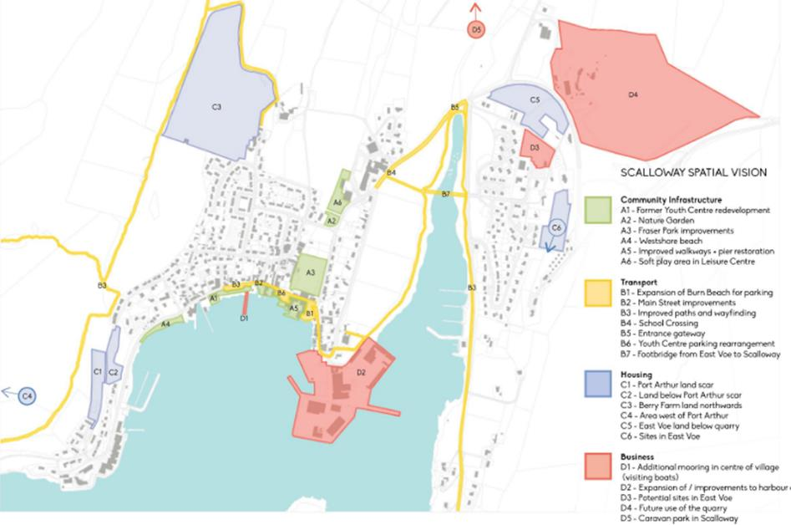
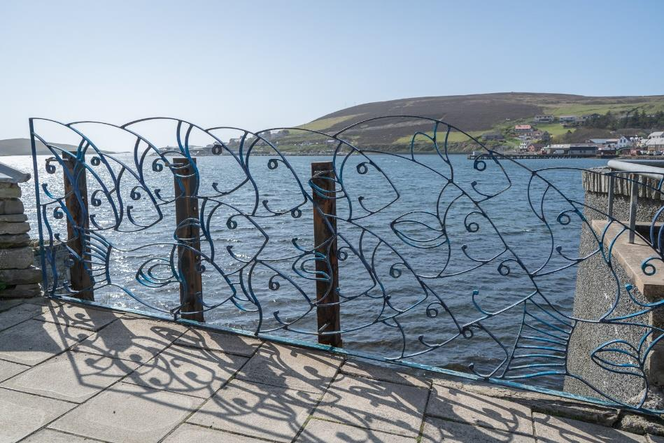

Contents
1. Foreword
2. Executive Summary
3. Introduction, Vision, Objectives and Community Profile
4. The Role of Scalloway Community Council
5. The Background to Re-Create Scalloway
6. Scalloway Today
7. Summary of the Public Consultation Events
8. Our Priorities for Action
9. Proposals for the Development, Use and Conservation of Land and Buildings
10. Proposals for Planning Policy
11. Evidence of Statutory Regard
12. Statement Regarding the Level of Community Support
13. Voluntary Statement on Statutory Impact Assessments
14. Strategic Environmental Assessment Considerations
15. Bringing the Local Place Plan Together
16. Implementation and Delivery
17. Summary of Progress to Date

Appendices

1. Foreword

Scalloway was in the privileged position to launch the first Local Place Plan in Shetland and among the first in Scotland. It came on the back of large scale community consultation that resulted in the launch of the Re-Create Scalloway proposal documents for the future growth of the locality in 2019. This consultation, in turn, was the basis for the first Local Place Plan and the foundation for a second round of consultation resulting in the Destination Scalloway masterplan document for the Scalloway waterfront and town centre area.

In the intervening years, several of the major projects that arose from these consultations have been completed, and new development ideas and factors have arisen. The Scalloway Local Place Plan v2/2026 seeks to capture the previous consultations with amendments to bring the document up to date, and to incorporate the revised statutory requirements of Scotland’s updated planning framework, including alignment with National Planning Framework 4 (NPF4).

Mark Burgess
Vice - Chair Scalloway Community Council
August 2026

2. Executive Summary
Local Place Plans are a statutory type of plan, introduced under the Planning (Scotland) Act 2019, giving communities an opportunity to develop proposals for the development and use of land in the place where they live. This document has been prepared to meet those statutory requirements, while retaining the community voice and evidence base built up through several years of engagement.
The Scalloway Local Place Plan sets out a 10-year vision for a thriving, resilient, and inclusive community. Building on extensive public engagement through the Re-Create Scalloway initiative and the Destination Scalloway masterplan, this plan identifies priority proposals for the development, use and conservation of land and buildings. It aligns with Scotland’s National Planning Framework 4 (NPF4), the Shetland Local Development Plan 2014 (LDP), and the Shetland Partnership Plan 2018–2028 (SPP).
It will be used by Shetland Islands Council’s Planning Service as a material consideration when determining planning applications and in taking forward the Council’s next Local Development Plan (LDP2). It will also provide an evidence base to support the Council, Scalloway Community Council and others when applying for funding to deliver on the community’s priorities.

Scalloway’s key priorities include:
- Expansion of Burn Beach for parking and public realm
- Improved waterfront walkways and moorings
- Reconfiguration of Main Street
- Improvements to Fraser Park
- Promotion of housing and tourism development

These proposals reflect community aspirations for better connectivity, enhanced public spaces, sustainable development, and inclusive participation. This document brings together the outputs of the Re-Create Scalloway public engagement events (2018), the Destination Scalloway masterplan (2022), and the policy context required by the updated statutory framework.

3. Introduction, Vision, Objectives and Community Profile

Introduction
Scalloway Community Council, supported by Shetland Islands Council, has led the development of this Local Place Plan. It builds on the Re-Create Scalloway consultations (2018–2019) and the Destination Scalloway masterplan (2022), incorporating feedback from residents, youth groups, businesses, and stakeholders.
The three key documents that underpin this plan are:
- Re-Create Scalloway Spatial Vision (May 2019) – identifies priority areas for improvement and reports on the outcomes of community engagement in 2018.
- Re-Create Scalloway Action Plan (May 2019) – sets out the actions required to deliver the priorities, identifies partners and potential funding sources.
- Destination Scalloway (Autumn 2022) – the masterplanning document arising from the Scalloway Waterfront and Town Centre Feasibility Study, focusing on the waterfront and town centre area.

Vision
Our vision for Scalloway is shaped around four themes:

Scalloway’s People
A community working together to deliver the Spatial Vision and Action Plan. Key to this is the active participation of members of the Scalloway community, community groups, volunteers, and community services all contributing to a thriving, healthy and happy community.

Scalloway and Place
A connected waterfront and vibrant village centre that promotes a distinctive, safer and attractive place for residents, visitors and businesses. The Local Place Plan creates the important link between land use planning and community planning, and Scalloway Community Council will work alongside Shetland Islands Council to seek funding opportunities to deliver the Spatial Vision and Action Plan.

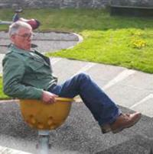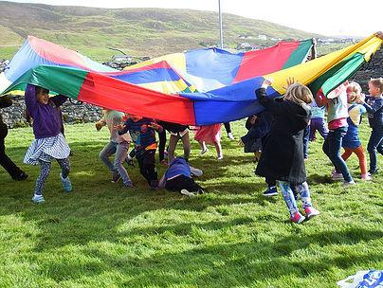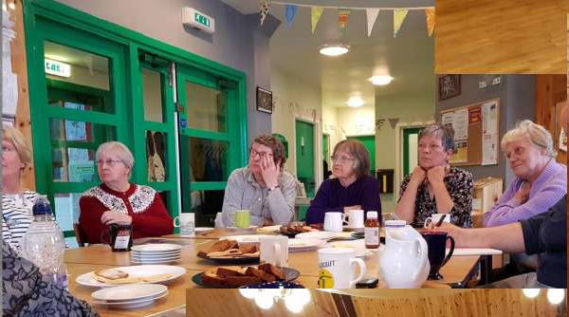

Community Participation
Inclusive engagement across all age groups, with young people helping shape the future. We shall continue to involve all of the community, use local knowledge and skills, and promote and encourage active participation.

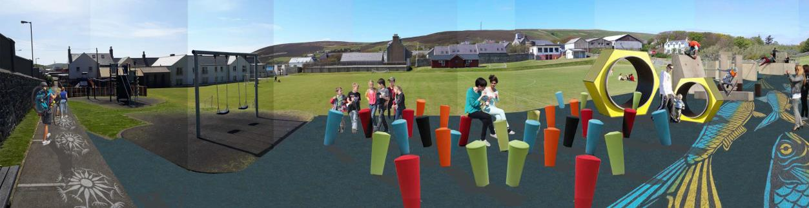

Equality and Accessibility
A well-connected village with accessible public spaces and services for all. We shall continue to facilitate community-led involvement in the future planning of homes and businesses, providing accessibility to public spaces, services and facilities.

Community Profile
Scalloway is a coastal village with a population of approximately 1,175 (2021 Census). The population range shows 26.8% aged 25–44 and 26.7% aged 45–64 at that time with 5.1% are children aged 0–4.There are a wide range of active community organisations. The village sits within its own National Scenic Area.

Figures supplied by SIC Children’s Services in November 2024 show that Scalloway Primary School has 23 pupils on the Early Years roll and 146 pupils in primary education. During 2018/19, a total of 1,315 students were enrolled at the Shetland UHI (formerly NAFC Marine Centre) on short, part-time and full-time courses and the college is undergoing a merger with Shetland College UHI which favours the Scalloway campus.

The settlement features a busy port, heritage assets including Scalloway Castle and a Conservation Area. The port area serves as key infrastructure of the Shetland fishing industry and aquaculture with key side processing and support industries. It is also used by large oil-related shipping, operating west of Shetland. The Scalloway Museum adjacent to Scalloway Castle attracts over 20,000 visitors per year and tourist-related industry is a growth area in the village.

Key issues identified through community consultation include traffic congestion, parking, vacant buildings, and limited housing development. The community has demonstrated strong engagement throughout this process, with over 600 participants involved in the Re-Create Scalloway programme and more in subsequent engagement.

4. The Role of Scalloway Community Council
Scalloway Community Council (SCC) strives to empower people, including those suffering disadvantage and inequality, to make Scalloway a better place to live, work, study and invest. Key to this is promoting active citizenship, equality and inclusiveness to help improve the quality of our community for present and future generations.

The Community Council is made up of 9 elected volunteers who work to express the views of our community to the local authority and other public bodies. We work collaboratively with other organisations to deliver our service and projects.

Scalloway Community Council members are committed to ensuring that Scalloway continues to be an attractive place for people of all ages to live, work and visit. The community council are mindful at all times to uphold the essence of the National Scenic Area, and seek to assure that development or change within the Conservation Area is complementary and sympathetic to the existing style and heritage of the settlement.

Scalloway Community Development Company (SCDC) is an independent charitable company limited by guarantee works with a board made up of volunteers and aims to work in partnership with the Community Council and Shetland Islands Council to:

- Advance the wellbeing and development of the community
- Advance the enhancement and conservation of the local environment, culture and heritage
- Advance the education of the public in matters relevant to the community.

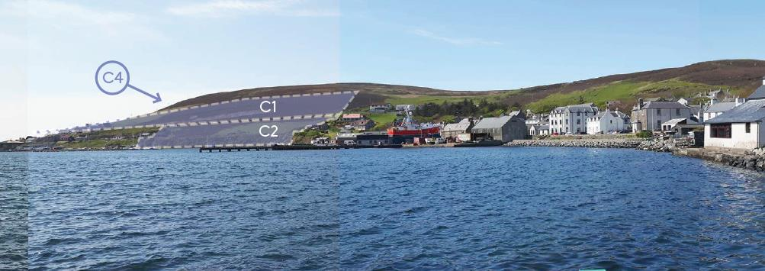

5. The Background to Re-Create Scalloway
To get to where we are now has taken a lot of hard work and commitment. Most importantly, it has been dependent on the Scalloway community engaging about the future of their village. Below are some of the key milestones that have led to the production of the Scalloway Local Place Plan.
Making Places Funding Application – October 2017
In October 2017, following discussions with Scalloway residents, business owners and Scalloway Community Council, Shetland Islands Council Planning and Community Planning & Development Services applied for funding to the Scottish Government’s Making Places Initiative. The intention was to develop a future vision for Scalloway through community workshops and events, with outcomes used to support the Council’s planning and community planning processes.
The Place Standard consultation (summer 2016) informed the application. Its top four priority areas for Scalloway – work and local economy, traffic and parking, facilities and amenities, and housing and community – formed the starting point for community engagement.

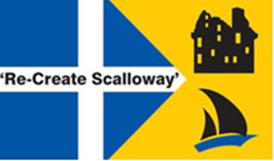

Funding Awarded – January 2018
In January 2018, funding was secured to take forward a future vision for Scalloway. A Working Group was established consisting of all members of Scalloway Community Council, community representatives, and staff from the Council’s Planning and Community Planning & Development Services.

Consultants Appointed – March 2018
Following a tender process, planning and design consultants GL Hearn and Iglu Studio were appointed to deliver the engagement events and draft the spatial vision and action plan. A competition at Scalloway Youth Centre resulted in the name ‘Re-Create Scalloway’ being chosen by young people.

Engagement Events and Workshops – May, June & November 2018
The first event was held in May 2018 when initial ideas for improvements were put forward by the community. In June 2018 these were developed further, and a follow-up event was held in November 2018 when the public voted on the priorities to take forward into the Spatial Vision and Action Plan.

The Outcomes – May 2019
In May 2019 the consultants finalised the Spatial Vision and Action Plan, which were published on the Council’s planning website. On 23 June 2019 a public drop-in session was held at Scalloway Youth Centre to present the outcomes and outline next steps, including the drafting of the Local Place Plan.

Destination Scalloway - June 2021
Following on from ReCreate Scalloway, consultants were appointed in June 2021 to further explore and take forward the priorities for improving the waterfront and town centre toward creating a masterplan for regenerating the area. The final report was produced in December 2022 entitled Destination Scalloway.
At the same time several other priority projects were progressed, such as public realm improvements, creation of a new campsite at Asta and production of a series of interpretive board for a heritage trail around Scalloway.

Waterfront Design - May 2025
Following the Destination Scalloway report a detailed design stage was activated in May 2025 with consultants subsequently appointed to draw up detailed designs, costed plans, seek the necessary consents and develop a business case for waterfront redevelopment. This moves the project toward the finding of funding for capital works and delivery on the ground.
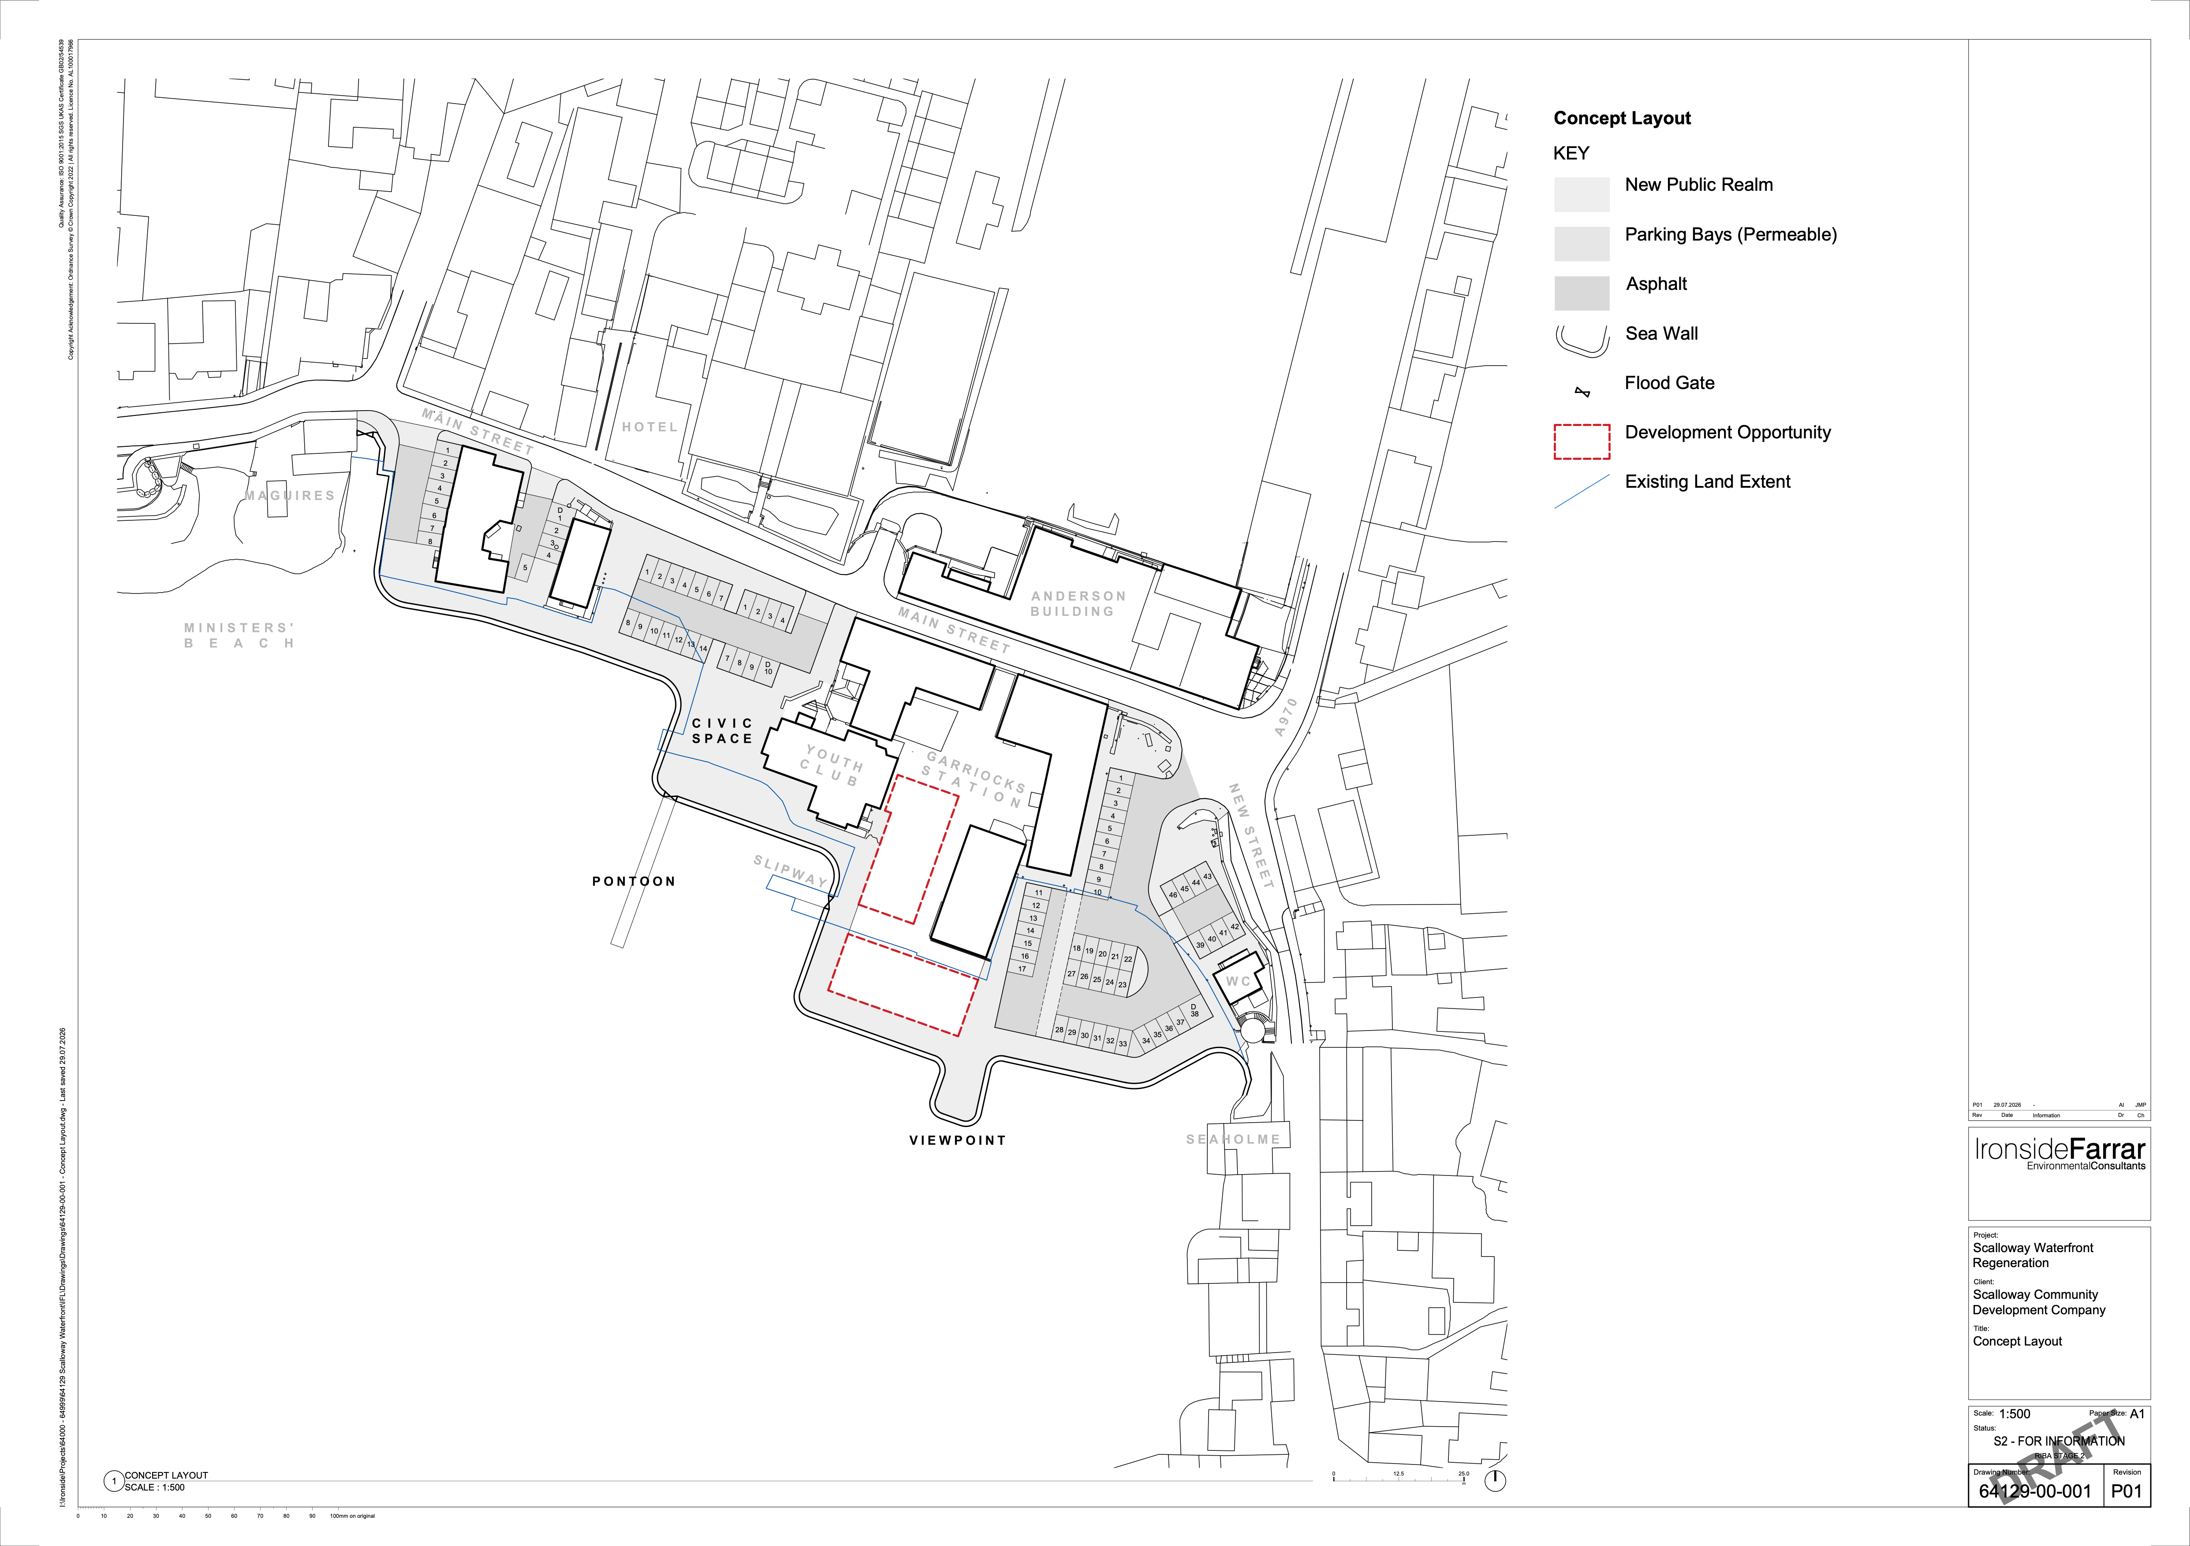
This detailed design work continues into September 2026 and nears completion.
Scalloway Waterfront Design Draft 2026


6. Scalloway Today
Scalloway is an attractive and thriving village with good provision of amenities and facilities. This includes its busy port and harbour, shops and businesses, college, primary school, health centre, youth centre, public hall and club houses.

Scalloway has a rich history, with its Castle, Conservation Area and Scalloway Museum being key assets to the village, which attract visitors and tourists from near and far. Scalloway also has strongly developed cultural ties with Scandinavian countries, in particular Norway, with Scalloway acting as the base of the crucial Shetland Bus resistance and refugees rescue operations for Norway during World War II.

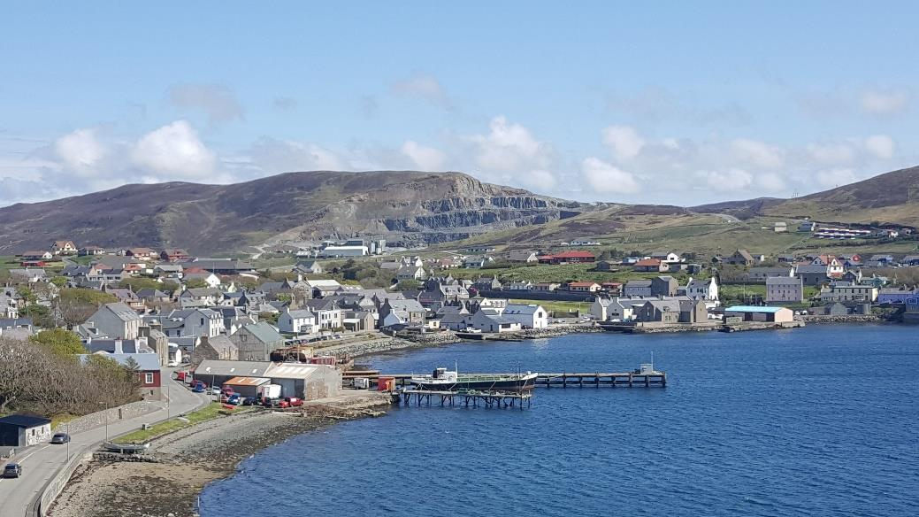

Assets and Opportunities
In the main core of the village, mostly along the waterfront, previous regeneration projects have resulted in an improved environment which has attracted new business. However, this has brought related issues of increased traffic, congestion and road safety along the village’s narrow streets. Parking and accessibility are now key issues to address.
The village also has a number of vacant and underused buildings and potential sites to redevelop and improve. The possibility of gaining land through coastal reclamation, along with the impacts of climate change on coastal protection from flooding, have also been considered.

Housing
With regard to housing, there has been little expansion within the central parts of the village as no development sites were promoted or identified in the current Local Development Plan (adopted 2014). In the last 20 years, approximately 88 dwellings have been completed in Scalloway. The majority came from large developments at East Voe of Scalloway (22 units, 2008/2009) and Upper Scalloway (32 units, 2023).
Scalloway’s population of 1,275 residents (2021 Census) is expected to continue to grow, based on demand. This is evidenced by 583 recent applicants on the Council’s housing register, of whom 238 have included Scalloway as a preferred area.
The Council ran a Call for Sites process for LDP2 in 2019. The information gathered will be used to consider potential future sites for housing, business and industry in Scalloway.

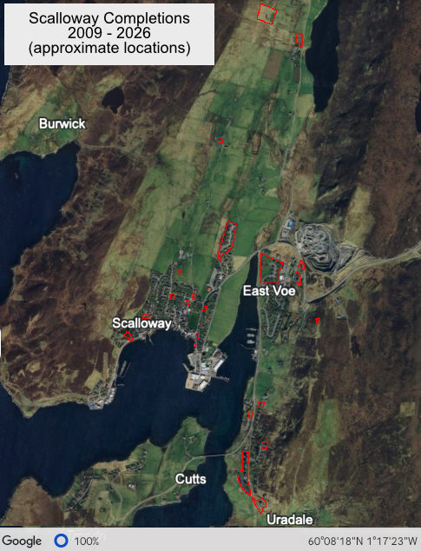


Community Strength
One of Scalloway’s greatest strengths is its people. The Re-Create Scalloway, Destination Scalloway and subsequent events demonstrated this with a high level of public engagement:
  - 214 people attended the workshops held in May, June and November 2018.
- 296 young people engaged at the Primary School and Anderson High School.
- 166 pre-consultation surveys were completed and returned to the Community Council.
- Destination Scalloway - 70 people engaged at open event.
- Destination Scalloway online - 375 hits through 271 devices.

7. Summary of the Public Consultation Events

The Re-Create Scalloway Spatial Vision provides a full report on the outcomes of the public consultation events and workshops. Below is a summary of the process that took place.

Pre-Consultation (Apr–May 2018): The project was named 'Re-Create Scalloway' via a youth centre competition, and a project website launched. Questionnaires were hand-delivered to every household and business, rating issues like community facilities, housing, walking routes, and traffic/parking. Separate surveys covered businesses and non-resident visitors. 166 responses received.
Information Gathering (May 2018): Workshops at the Public Hall covered community facilities, transport, and housing. Young people tested village accessibility on a dedicated walk.
Identifying Priorities (June 2018): Follow-up events refined ideas from May, adding a new 'business opportunities' theme. Over 100 young people engaged across the Primary School, Anderson High School, and NAFC; 77 adults attended Public Hall workshops, plus a dedicated 60+ session.
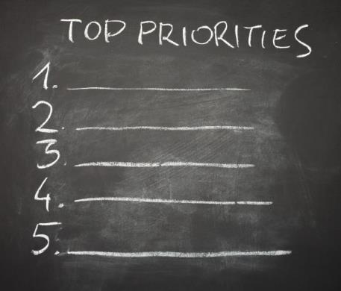
Voting for Priorities (Nov 2018): A voting event (in-person and online) drew 157 participants, narrowing 24 options down to 18 for the Action Plan.

Scalloway Local Place Plan – Supplementary Planning Guidance
The Re-Create Scalloway findings were used to prepare Scalloway’s first Local Place Plan (2020). Place Plans are a new part of the development plan process which allows local communities to prepare their own plan, setting out their proposed allocations for the use and development of land. The Local Planning Authority is required to ensure that Local Place Plans inform the Local Development Plan (LDP). SIC has adopted the Scalloway Local Place Plan as Supplementary Guidance to the adopted LDP

Destination Scalloway
Following on with public and professional consultation, refining what has already come from Recreate Scalloway and the Local Place Plan and focussing on the Scalloway Waterfront and Town Centre. The first community engagement was held in the form of a drop-in public exhibition at Scalloway Public Hall. This was held over Friday 19th (1-5pm) and Saturday 20th (10am-5pm) November 2021. A set of 14 A1 boards were displayed explaining the project and setting out numerous questions and proposals for the area. Two members of the design team were present to answer questions and discuss ideas with the more than 70 local people who attended.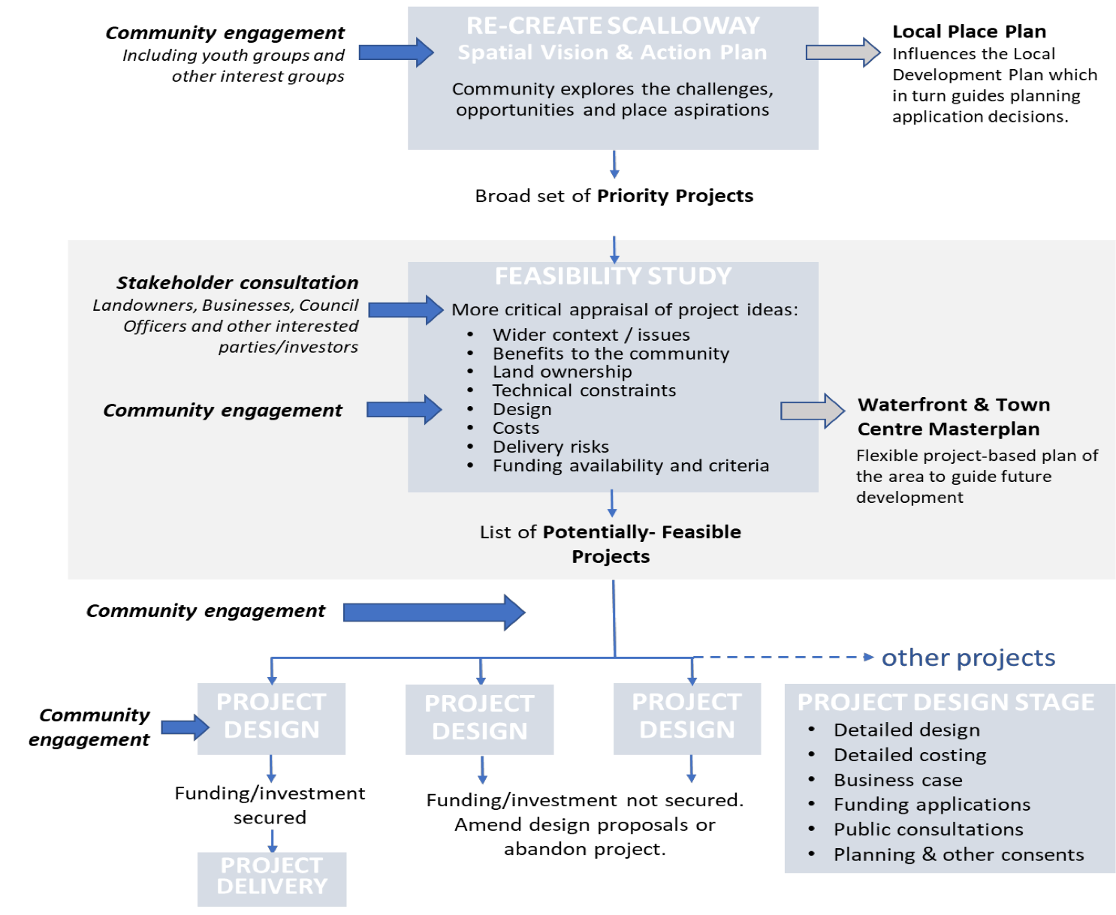
A virtual public consultation room was also made available to reach a wider audience and to cater for those not able to make it in person. Each board could be viewed/ downloaded, and comments submitted via the survey tool. It was online for three weeks (19th Nov to 10th Dec) and received 375 hits through 271 individual devices with an average spend time of over 6 minutes.

8. Our Priorities for Action
Scalloway Community Council and Scalloway Community Development Company have been, and continue to be, committed to delivering the priorities of the Spatial Vision as set out in the Action Plan. A number of these priorities could be achieved through coordinated projects.

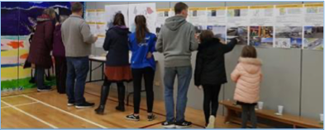

Burn Beach To Minister’s Beach Expansion & Improvements
Our vision for Scalloway sets out to enhance Main Street and the waterfront area to promote a distinctive, safer and attractive place for residents, businesses and visitors. Three of the highest priorities for improvement are located in the centre of the village:

- Additional parking at Burn Beach for cars, buses and motorhomes
- Improved waterfront walkways and piers
- Reconfiguration of Main Street to reduce congestion
Taking a coordinated approach ensures that we do not consider improvements in isolation and that we are aware that changes in one area of the village could impact upon another. For example, if some parking were to be lost along Main Street to reduce congestion, improve safety and create more space for public realm improvements, it would need to be accommodated elsewhere. The expansion of Burn Beach through coastal reclamation could be one potential way of achieving this.
Scalloway Waterfront Design Draft 2026

Coastal reclamation is considered as an option, and the potential to incorporate new waterfront walkways, public realm areas, boat moorings and civic amenities. This would make the village more attractive and help promote health benefits for visitors and residents. The waterfront walkways would also incorporate flood prevention measures to reduce the impacts of instances of flooding, and those projected through climate change and sea-level rise in the centre of the village.
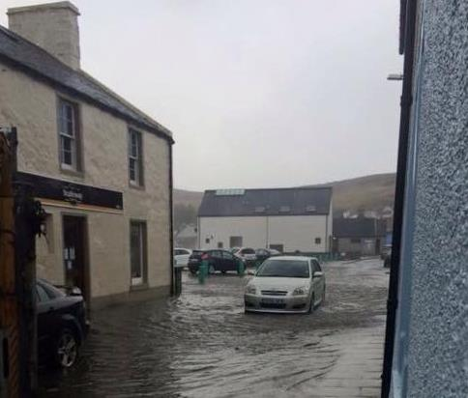
Flooding is rare but a genuine issue for central Scalloway

9. Proposals for the Development, Use and Conservation of Land and Buildings
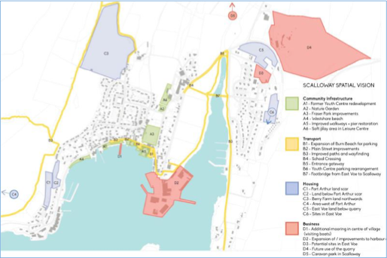
The following proposals have been identified through community consultation and are presented in the four thematic categories established through the Re-Create Scalloway. Destination Scalloway and Scalloway Local Place Plan v2 process. These constitute the formal proposals of this Local Place Plan v2 for the purposes of the Planning (Scotland) Act 2019 and NPF4.

Identity
- Redevelopment of the Former Youth Centre The former youth centre site has been cleared. It presents an opportunity for new community, industrial or mixed-use development in a central village location. This was the top priority identified by the community from an origin in November 2018.
- Reconfiguration of Main Street. Improve safety, reduce congestion, and enhance the public realm along Main Street. Closely linked to parking provision at Burn Beach.
3. Improved public amenity. Improved public amenity along the waterfront, and aesthetically enhanced coastal delineation with sea wall and viewpoints, and civic space for locals and visitors

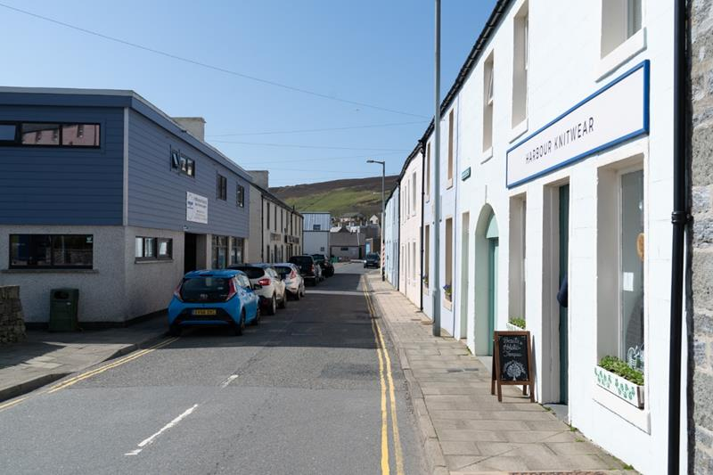

Movement
- Expansion of Burn Beach and Waterfront for Parking. Coastal reclamation to increase parking capacity and support tourism. Would relieve Main Street parking pressure and enable public realm improvements. Inclusion of motorhomes, vans cars and buses in traffic and pedestrian complementary separation.
- Improved Waterfront Walkways. Enhance access and connectivity along the waterfront, incorporating potential flood prevention measures, moorings for visiting boats, and links to Burn Beach.
- Safe Crossing to Scalloway Primary School. Improve pedestrian safety for children and families on routes to the school.
- Footbridge from East Voe. Explore feasibility of a new pedestrian link connecting East Voe to the village centre.
- Improved Way-finding. Expand interpretive signage and walking routes across Scalloway (a network of interpretive panels has been installed; potential for further expansion).
- Improved Active Travel. Enhance “Active Travel” routes from Sundibanks toward the village and amenities. Safe pedestrian and non-motor vehicle routes from the Tingwall Valley to Scalloway to develop leisure potential.

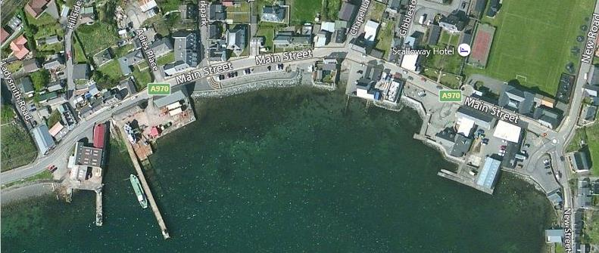

Environment and Facilities for Young People
- Fraser Park Improvements. Upgrade play equipment and landscaping for youth use. Improve boundaries. Explore reconfiguration and improvement of the playing field.
- Potential Sandy Beach at Westshore. Investigate feasibility and environmental impact of creating a sandy beach at Westshore.
- Nature Garden. Identify a site and create a biodiversity-focused space for education and recreation, in partnership with schools and volunteers.

Planning for Investment
- Soft Play Facility. Explore a multi-use model for indoor play and community use, with phased delivery and community ownership.
- Housing Development at Port Arthur and Adjacent Sites. Promote sites for affordable and sustainable housing, including land previously considered and available at Port Arthur, adjacent sites and land to the west of Port Arthur. Exploration of sites suggested by public input around Berry Farm, if available. Windfall sites in centre of village, where available.
- Tourism Infrastructure. Develop moorings and visitor amenities in the village centre to support the tourism economy. Develop marine tourism market with infrastructure and publicity. Recognise and enhance further potential of Scalloway Castle. Development of tourism through further visitor attractions. Liaison with Swan Trust for berthing. Develop market for direct cruise vessels visits to Blacksness and potential of new West Pier.
- Scalloway Harbour Masterplan Implementation. Advance industrial and marine development at Blacksness in line with community priorities and in collaboration with SIC Ports and Harbours. The main initial focus of this, as also highlighted by the Shetland Islands Council, is a replacement of the West Pier which is currently under-utilised due to historic damage. A replacement is expected to be complementary to the improvements to waterfront space between Burn Beach and Ministers Beach.
- Community Energy. Collaboration with partners toward the development of a district heating scheme for the village. Energy conservation, production and efficiency measures to meet the identified need to reduce fuel poverty and achieve Net Zero targets.
- Marine Access and Management.Collaboration with partners toward provision of a third marina, potentially at Westshore or Eastshore subject to Blacksness developments. Potential of boat lift facilities to support inshore industry. Improved recovery of marine litter in harbour environs. Slipway and quayside access for leisure and visitor craft.
- Motorhome Reception. Further developments and enhancement at Scalloway Caravan Park. Potential footpath to and from Scalloway to improve visitor connection to village.
- Business Development. Business and commercial floorspace increase in village area. Potential development sites in Waterfront redevelopment and vacant or repurposed lots within the village. Shipyard site expansion.
- Community Facilities. Improvements to historic Scalloway Public Hall through increased space availability, energy usage improvements and modernisation of interior. Creation of better accessibility infrastructure. Enhancement and sustainability measures for community facilities, though energy usage, diversification and enhancement.
- Environmental Investment. Transport and traffic management improvements. Support of Electric Vehicle technology. Cycle and walking routes. Support of green space management.
- Outdoor pursuits. Development of novel or underrepresented outdoor activities in Scalloway area for locals and visitors.

10. Proposals for Planning Policy
In accordance with the Planning (Scotland) Act 2019, this Local Place Plan includes proposals regarding planning policy. These are put forward in the context of Scalloway’s rural island setting and the specific challenges facing small coastal communities in Shetland.

Suggested NPF4 Policy Amendments

NPF4 Policy 15 – Local Living
Policy Proposal: Adapt the ‘20-minute neighbourhood’ concept to suit rural Shetland contexts, recognising that car dependency and geographic isolation require a distinct approach to local living.

NPF4 Policy 2 – Climate Mitigation and Adaptation
Policy Proposal: Permit low-density, energy-efficient housing in rural settlements where it supports community resilience and does not conflict with climate objectives.

NPF4 Policy 6 – Design, Quality and Place
Policy Proposal: Recognise vernacular and community-led design as valid expressions of design quality in planning decisions.

NPF4 Policy 13 – Sustainable Transport
Policy Proposal: Include community transport and digital infrastructure as valid alternatives to conventional public transport in rural contexts.

NPF4 Policy 7 – Historic Assets and Places
Policy Proposal: Enable flexible reuse of historic buildings to support community resilience, with appropriate safeguards for heritage assets.

Suggestions for Addressing Policy Gaps

Community Wealth Building and Large-Scale Development Mitigation
Policy Objective: Introduce measures requiring community impact assessments for large-scale proposals, including economic resilience checks and mitigation strategies. Ensure planning policy supports community wealth building without stifling fair competition.

Meanwhile Land and Building Use
Meanwhile land, also known as meanwhile use, refers to the temporary occupation of vacant buildings or land for socially beneficial purposes until permanent commercial development or new ownership is established.

This strategy transforms idle spaces into active community assets such as pop-up shops, creative workspaces, community gardens, and temporary housing, thereby maintaining area vibrancy and reducing the economic burden on landowners

Policy Objective: Provide express permission for, and encouragement of, meanwhile uses where they support community wellbeing and do not conflict with long-term planning objectives.

Rural Development and Resilience
Policy Objective: Underpin and increase rural resilience by permitting development which demonstrably seeks to sustain small communities and their local economies.

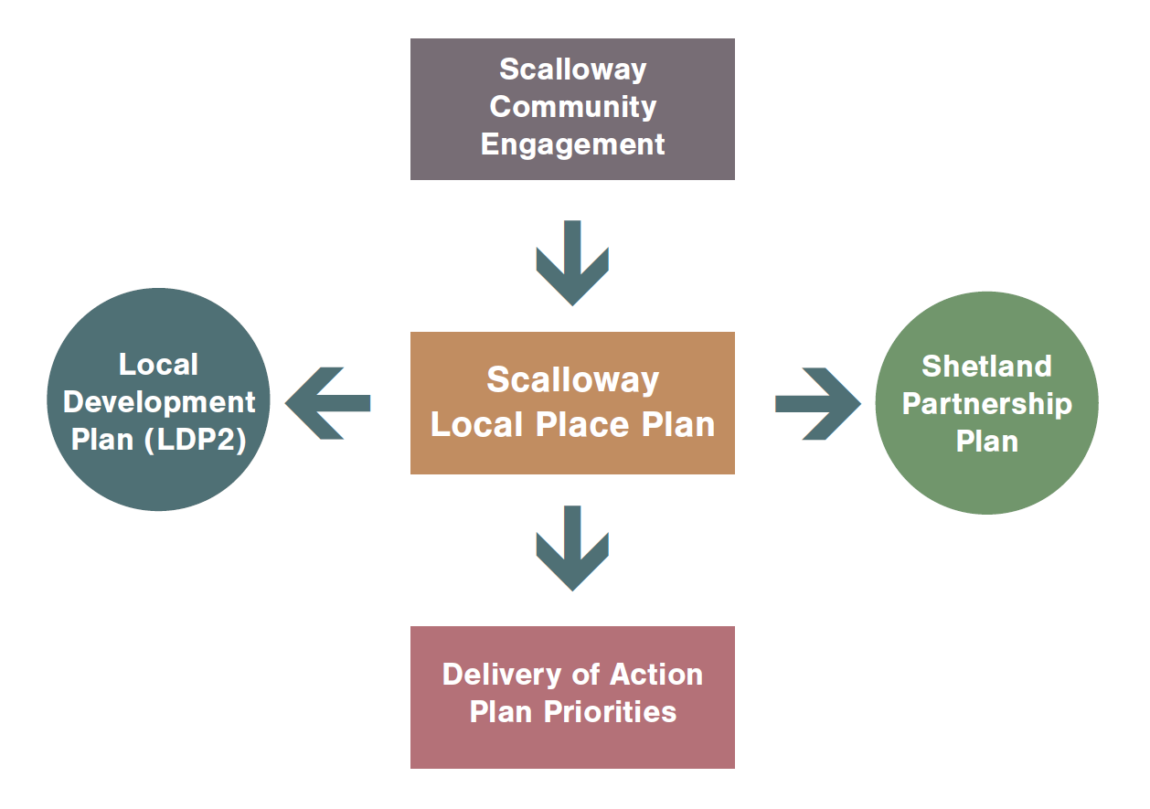

11. Evidence of Statutory Regard
This section demonstrates the alignment of the proposals in this Local Place Plan with relevant national and local planning policy, as required under the Planning (Scotland) Act 2019.

Policy Alignment
Proposal | NPF4 Policies | LDP Policies | SPP Priorities
Burn Beach Expansion | NPF4 Policy 13 (Sustainable Transport), NPF4 Policy 2 (Climate Mitigation) | LDP Policy TRANS1 (Integrated Transport) | Place, Money
Waterfront Walkways | NPF4 Policy 20 (Blue and Green Infrastructure), NPF4 Policy 14 (Design, Quality and Place) | LDP Policy CF2 (Open Space) | Place, People
Main Street Reconfiguration | NPF4 Policy 13 (Sustainable Transport) | LDP Policy GP2 (General Requirements for All Development) | Participation, Place
Fraser Park Improvements | NPF4 Policy 21 (Play, Recreation and Sport) | LDP Policy CF2 (Open Space) | People, Place
Tourism Infrastructure | NPF4 Policy 30 (Tourism) | LDP Policy ED2 (Business Development) | Money, Place
Soft Play Facility | NPF4 Policy 15 (Local Living) | LDP Policy CF1 (Community Facilities and Services) | People, Participation
Nature Garden | NPF4 Policy 3 (Biodiversity), NPF4 Policy 20 (Blue and Green Infrastructure) | LDP Policy NH3 (Natural Heritage) | Place, People
Housing Development | NPF4 Policy 16 (Quality Homes), NPF4 Policy 17 (Rural Homes) | LDP Policy H3 (Housing Development), LDP Policy H4 (Affordable Housing) | People, Money
Harbour Masterplan | NPF4 Policy 29 (Rural Development), NPF4 Policy 13 (Sustainable Transport) | LDP Policy ED1 (Support for Business and Industry) | Money, Place

Potential Conflicts and Mitigation
Proposal or Policy | Potential Conflict | Relevant Document | Suggested Mitigation
Burn Beach Expansion | Coastal reclamation may conflict with natural heritage and flood risk policies | LDP Policy NH1 (Natural Heritage), NPF4 Policy 22 (Flood Risk) | Use permeable surfaces, include flood modelling, consult SEPA early
Waterfront Walkways | Visual impact and accessibility concerns | NPF4 Policy 14 (Design, Quality and Place) | Inclusive design, community-led layout, phased implementation
Main Street Reconfiguration | Loss of parking may affect local businesses | SPP Priority: Money | Link to Burn Beach expansion, consult traders, provide alternative parking signage
Fraser Park Improvements | Noise and safety concerns for nearby residents | LDP Policy GP2 | Install buffer planting, limit hours of use, involve youth groups in design
Tourism Infrastructure | Overdevelopment risk in scenic areas | NPF4 Policy 6, LDP Policy NH1 | Sensitive siting, design codes, seasonal use strategy
Soft Play Facility | Viability and funding challenges | SPP Priority: Money | Explore multi-use model, phased delivery, community ownership
Nature Garden | Land availability and maintenance burden | LDP Policy NH3 | Use underused land, partner with schools and volunteers
Housing Development | Density and amenity concerns | LDP Policy H6 (Amenity Space), NPF4 Policy 16 | Include green space, low-impact design, community consultation
Harbour Masterplan | Industrial expansion may conflict with heritage and landscape | NPF4 Policy 7, LDP Policy HE1 (Historic Environment) | Heritage impact assessment, design review, stakeholder engagement
Community Wealth Building | Risk of perceived anti-competition stance | NPF4 Policy 25 (Community Wealth Building) | Frame as resilience and wellbeing measure, include economic impact assessment
Meanwhile Use Proposal | Temporary uses may conflict with long-term zoning | LDP Policy GP1 (Sustainable Development) | Time-limited permissions, community benefit reporting
Rural Development Proposal | Risk of inconsistency with compact growth principles | NPF4 Policy 2 (Climate Mitigation) | Define rural resilience zones, link to transport and energy strategies

12. Statement Regarding the Level of Community Support
The Scalloway Local Place Plan is the result of extensive community engagement through the Re-Create Scalloway initiative and Destination Scalloway masterplan. Over 600 individuals participated in surveys, workshops, youth events, and public meetings. The plan reflects broad community support and incorporates feedback from all age groups, including targeted youth engagement and landowner consultation.

The plan has been prepared by Scalloway Community Council and is supported by its members, the Scalloway Community Development Company, and Shetland Islands Council’s planning and community planning services.

Key initial engagement
Figures included (2018 - 2019. See ReCreate Scalloway Documents):
- 214 people attended the Re-Create Scalloway workshops (May, June and November 2018).
- 296 young people engaged through the Primary School, Anderson High School and NAFC Marine Centre.
- 166 pre-consultation surveys completed and returned.
- 157 people voted on priorities at the November 2018 event.

Secondary Consultations (2021-2022)
Drop-in public exhibition at Scalloway Public Hall. This was held over Friday 19th (1-5pm) and Saturday 20th (10am-5pm) November 2021. A set of 14 A1 boards were displayed explaining the project and setting out numerous questions and proposals for the area. Two members of the design team were present to answer questions and discuss ideas with the more than 70 local people

Stakeholder Consultation — Destination Scalloway Masterplan (2021–22)
Alongside the wider public engagement, Ironside-Farrar consultants held targeted discussions with over 20 waterfront businesses, community organisations and statutory bodies between August 2021 and February 2022, as part of the Scalloway Waterfront & Town Centre Feasibility Study. Those consulted included GAADA (visual arts charity, then exploring a new accessible arts facility), Malakoff Ltd (marine/diving operations at Moore's Yard), H. Williamson & Sons (marine electronics), Scalloway Meat Company, The Swan Trust, Scalloway Museum, Scalloway Youth Centre Trust, Scalloway Boating Club, Scalloway Motors, the Kiln Bar, the Cornerstone Café, the Walk Scalloway Group, and Shetland Islands Council's planning, roads, and ports & harbours teams.
Recurring themes included:
- Parking pressure along Main Street and shared courtyards, and support for expanding the Burn Beach car park (with a clear preference for keeping its existing entrance point)
- Support for repairing and extending waterfront walkways and piers, including berthing for visiting yachts and The Swan
- Flood risk and the need for durable flood defences, with scepticism about rock armour as a solution
- Pedestrian safety concerns, particularly at school drop-off and the New Road corner, and demand for a safe crossing from East Voe
- Land scarcity constraining growth for several local businesses and for the harbour itself
- Harbour growth pressures, with SIC Ports & Harbours flagging future investment needs and the incompatibility of large vessel operations with leisure/personal watercraft
- Museum capacity pressures from cruise-ship coach traffic (pending Castle restoration), and calls for visitors to be drawn further into the village
- Fraser Park's disrepair — unstable boundary walls, ageing equipment — and the lack of a dedicated maintenance funding stream
This stakeholder engagement directly informed the Destination Scalloway masterplan (2022) and underpins several proposals carried forward into this Local Place Plan, including waterfront walkway improvements, Burn Beach expansion, Main Street reconfiguration, Harbour Masterplan implementation, and Fraser Park improvements.

Web-based consultation received 375 hits through 271 individual devices with an average spend time of over 6 minutes.

Tertiary Consultation
August 2025 - SYCC Open day at SYCC for public feedback on current projects and Local Place Plan. (Attendee numbers not recorded)

13. Voluntary Statement in Relation to Statutory Impact Assessments
The Scalloway Local Place Plan has voluntarily considered the following statutory impact assessment frameworks in the development of its proposals:

Equalities Impact Assessment (EQIA)
Proposals have been developed with inclusive design and access in mind, ensuring that improvements to public spaces, walkways and facilities are accessible to all members of the community regardless of age, disability or other protected characteristics.

Child Rights and Wellbeing Impact Assessment (CRWIA)
Youth involvement has been central to the process. Proposals for Fraser Park, improved walkways and safe school crossings directly address the needs of children and young people, who were actively engaged in shaping the plan through dedicated workshop sessions.

Fairer Scotland Duty (FSD)
The plan addresses inequalities in transport access and housing provision, promoting affordable housing options and improved connectivity for all residents.

Island Communities Impact Assessment (ICIA)
All proposals have been developed with recognition of the distinctive challenges facing island and rural communities, including geographic isolation, limited public transport, and the need to sustain local services and economic activity.

14. Further Consideration Regarding Strategic Environmental Assessments
All proposals have been reviewed against the key Strategic Environmental Assessment topics. The following summarises the considerations for this Local Place Plan:
- Biodiversity – The nature garden proposal and waterfront improvements incorporate biodiversity enhancement measures.
- Climate – Flood mitigation is embedded in waterfront walkway proposals; energy-efficient housing development is promoted.
- Soil – Coastal reclamation proposals will require geotechnical assessment and appropriate mitigation.
- Water – Burn Beach expansion and waterfront works include consultation with SEPA on flood risk and water quality.
- Air – Main Street reconfiguration aims to reduce congestion and associated emissions.
- Landscape – All proposals in the National Scenic Area will be assessed for landscape and visual impact.
- Cultural Heritage – Reuse of historic buildings and development within the Conservation Area will be assessed against heritage policies, with input from Historic Environment Scotland where required.

15. Bringing the Local Place Plan Together
Scalloway’s active community are keen to see their village develop in a sustainable way for the benefit of current and future residents. To enable this to happen we need to ensure that all stakeholders – including the planning and community planning & development services of the Council – are committed to working together to achieve our goals.



1. The Shetland Local Development Plan (LDP2)
The Scalloway Local Place Plan will be used to inform the production of the Council’s next Local Development Plan (LDP2). LDP2 will identify future areas for development and include policies used to consider planning applications. In preparing this plan we have taken account of the current Local Development Plan (2014), National Planning Framework 4, and the Shetland Partnership Plan. In particular, we wish to ensure that Scalloway:
- Makes the best use of its assets to build a sustainable future, creating high quality, diverse and sustainable places that promote well-being and attract investment.
- Encourages sustainable economic development to create strong, healthy, vibrant communities where diversity is recognised and celebrated.
- Conserves and promotes its historic environment, culture and quality of life.
- Encourages new development that is environmentally sensitive and accessible to all.
- Supports better access, in particular active travel by foot, cycle and public transport.
- Has measures in place to reduce carbon emissions and includes proposals to mitigate and protect against the effects of climate change, in particular sea level rise and coastal flooding.

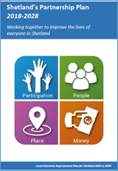
2. The Shetland Partnership Plan (2018–2028)
The Shetland Partnership Plan is a plan for all communities and community planning partners in Shetland. It identifies a shared vision and priorities for all of us to work towards, both individually and collectively, to improve the lives of everyone in Shetland. The Plan is based on four shared priorities: Participation, People, Place and Money. The Local Place Plan contributes to all four priorities and we have incorporated them into our vision for Scalloway.

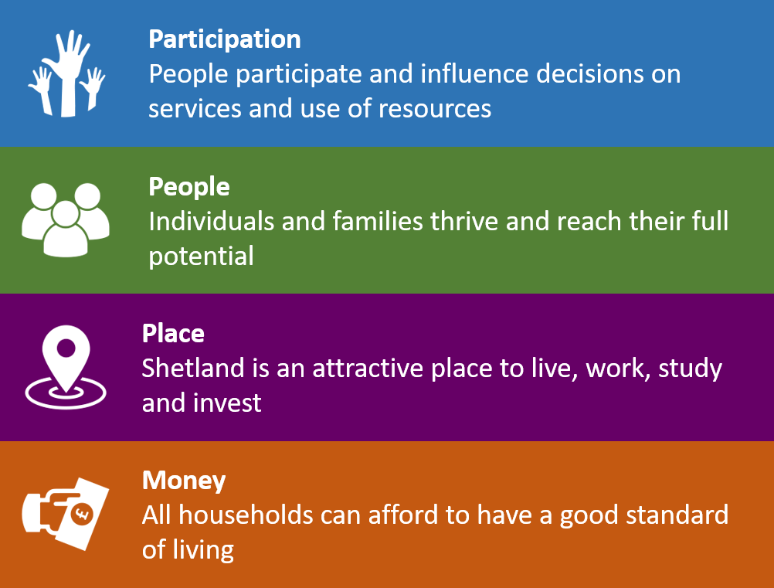

3. The Place Principle
Community activity from Re-Create Scalloway onwards has focused on how Scalloway can be a better place – more welcoming, accessible, safer, active, connected and adventurous. We shall adopt the Scottish Government’s Place Principle in taking forward our Local Place Plan:

Place is where people, location and resources combine to create a sense of identity and purpose, and is at the heart of addressing the needs and realising the full potential of our communities.

Places are shaped by the way resources, services and assets are directed and used by the people who live in and invest in them. A more joined-up, collaborative, and participative approach to services, land and buildings, across all sectors will enable better outcomes for everyone and increased opportunities for people and communities to shape their own lives.

16. Implementation and Delivery
Scalloway Community Council recognises that we must take the following steps to make the Local Place Plan a success:

1. Working Together
The Local Place Plan v2, ReCreate Scalloway Spatial Vision and Action Plan, and Destination Scalloway are the product of Scalloway residents, Scalloway Community Council, Scalloway Community Development Company, schools, youth groups, businesses, organisations and Council services working together. Collectively these documents provide the future vision for Scalloway which sets out how the village can change and develop over the next 5 to 15 years. They should be seen and used as ‘living’ documents, which are flexible to future changes.
We shall continue to work together to ensure that the priorities for the village remain relevant and achievable. We will work alongside Council Services and other stakeholders to implement, deliver and update the Action Plan on a regular basis.

2. Engagement in Planning and Community Planning Processes
On behalf of the community, we shall actively engage, influence and contribute to the Shetland Local Development Plan (LDP2) and the Shetland Partnership Plan.

3. Leadership
The Community Council, Scalloway Community Development Company and Shetland Islands Council will provide the leadership to drive forward the Local Place Plan. Support will be provided by the Council’s Planning and Community Planning & Development Services, and we shall work closely with other Council services, community planning partners, agencies and other stakeholders.

4. Making a Difference
It is important that we show what is being achieved throughout the lifetime of the Local Place Plan. We shall keep the community regularly informed of the progress we make and our successes. A number of priorities and actions have been identified as being achievable in the short term and we shall work hard to ensure this happens.

5. The Continued Involvement of our Community
Active public participation is key to our success and we require the help of the community to make Scalloway the best place it can be. We shall therefore ask people what projects they would like to be involved in, assist them and provide opportunities to be involved.

17. Summary of Progress to Date
In the period since the publication of the Spatial Vision and Action Plan, and Destination Scalloway, Scalloway Community Council, Council Services and Scalloway Community Development Company have been busy applying for funding to help deliver the priorities for the village and delivering projects that were identified through public consultation.
In November 2019 we were successful in obtaining a share of £205,000 from the Scottish Government’s Town Centre Fund. This money was used towards delivering some of the priorities in the Action Plan, including:

- The demolition of the old youth centre.
- The installation of improved signage and way-finding throughout the village.
- The reconfiguration of parking arrangements by Scalloway Youth and Community Centre.

The work done through the Re-Create Scalloway consultation led to a further release of funding in 2021 to carry out the Scalloway Waterfront and Town Centre Feasibility Study, which yielded the Destination Scalloway masterplan document. This brought in further priorities from community feedback, including:

- Improvements to Scalloway Public Hall to utilise unused areas and provide disabled access to the first floor.
- A revisit of the idea to connect Scalloway to East Voe.
- Creation of a tourist amenity to berth the historic vessel Swan and allow access.

The Destination Scalloway masterplan enabled SCDC to access £200,000 in funding to take the waterfront improvements to the detailed design stage, with consents and costings to be delivered in 2026.

Further developments worth noting include:

- Engagement with SIC Ports and Harbours regarding potential development of Scalloway Harbour at Blacksness.
- Collaboration with partners toward the development of a district heating scheme for the village.
- Collaboration with partners toward provision of a third marina, potentially at Westshore , Midshore or Eastshore if Blacksness developments allow.
- Completion of the Scalloway Caravan Park at Asta and successful operation for 3 years.
- Further heritage trail signage and interpretation materials being developed.

We shall continue to work alongside our partners (see Appendix) to seek out funding opportunities to deliver the priorities.

Appendices

Appendix A: Community Engagement Summary
- 14 people attended the workshops held in May, June and November 2018.
- 296 young people engaged at the Primary School and Anderson High School.
- 166 pre-consultation surveys were completed and returned to the Community Council.
- A voting event (in-person and online) drew 157 participants, narrowing 24 options down to 18 for the Action Plan, November 2019
- 20 waterfront businesses, community organisations and statutory bodies between August 2021 and February 2022, as part of the Scalloway Waterfront & Town Centre Feasibility Study.
- 375 hits through 271 individual devices with an average spend time of over 6 minutes.
- Scalloway Community Development Company held an open day in August 2025, where all the major active projects were on display and the Scalloway Local Place Plan V2 Draft was aired.
A full summary of the Re-Create Scalloway and Destination Scalloway engagement processes is contained in the Spatial Vision (May 2019) and the Destination Scalloway masterplan document (2022), both available on the Shetland Islands Council planning website.

Appendix B: Maps of Development Zones and Proposals

Appendix C: List of Consultees and Partners

Scalloway

Scalloway Community Council

Scalloway Community Development Company

The Scalloway Community

The Scalloway Business Community

Local Councillors

Shetland UHI (NAFC Marine Centre)

Scalloway Youth and Community Centre

Scalloway Primary School

Fraser Park Trust

The Scalloway Museum & Shetland Bus Friendship Society

Scalloway Boating Club

Scalloway Churches

Royal British Legion (Scalloway Branch)

Crossreach

Shetland Islands Council

Development Services

Infrastructure Services

Community Health and Social Care

Children’s Services

Corporate Services

Key Agencies

NHS Shetland

Highlands and Islands Enterprise

Historic Environment Scotland (HES)

Scottish Environment Protection Agency (SEPA)

NatureScot (formerly Scottish Natural Heritage)

Scottish Water

ZetTrans

Crofters Commission

Sport Scotland

Others

Hjaltland Housing Association

Voluntary Action Shetland

Appendix D: Supporting Documents

The following documents form part of the evidence base for this Local Place Plan and are available on the Shetland Islands Council planning website:
- Re-Create Scalloway Spatial Vision (May 2019)
- Re-Create Scalloway Action Plan (May 2019)
- Destination Scalloway Masterplan (2022)

Appendix E: Scalloway LPP v1 Endorsement

Endorsement of Scalloway LPP v1 by Councillor Alistair Cooper
I am pleased to present the first Local Place Plan to be prepared in Shetland. This is the outcome of hard work and commitment by the Scalloway Community Council working alongside their community, Council services and all those with an interest in the future of Scalloway.
The Scalloway Local Place Plan has been prepared by Scalloway Community Council following the outcomes of the ‘Re-Create Scalloway’ consultation and workshops that took place during 2018.
The Scalloway Community has been the driver behind this work and this is very much a plan for the people of Scalloway. Their involvement in Re-Create Scalloway has helped guide how the village can develop in the future and ensure that it continues to be an attractive place to live, work, study, play and invest.
To help achieve this, the Scalloway Local Place Plan sets out a future vision for how the village could be improved and the actions required to help achieve this.
The community working together has been the key to success so far and I hope this continues to act as a benchmark for future engagement in planning and community planning in Shetland.

Alastair Cooper
Councillor, Shetland Islands Council

This document is a draft and subject to further refinement and community verification prior to submission to Shetland Islands Council.

